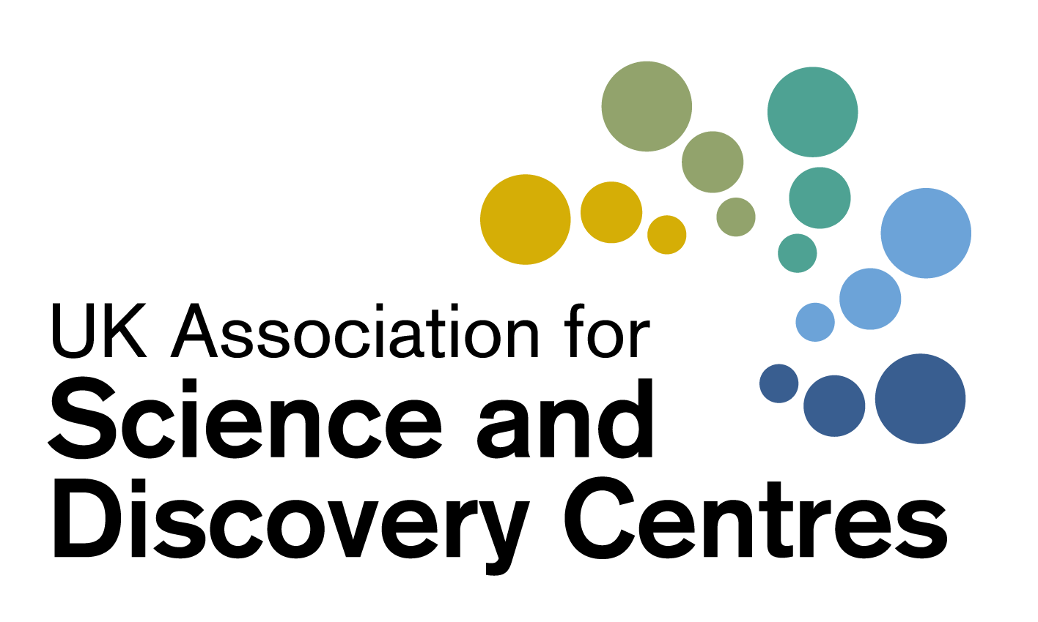
Treasurer’s report

ASDC AGM September 2016

Annual Accounts for 2015-16
The accounts are detailed in the ASDC Accounts 2015-16 from page 15 onwards

Financial results for the year 2015-16
Total income for the year was £995,063. This is an increase on 2014-15 (£305,750). Income from Projects was up to £947,704 (from £228,782 in 2014-15). There was no increase in the level of the membership fees; some members have chosen not to renew due to financial constraints.

A summary of income during the past three years is shown below.
Income
 | 2013-14 | 2014-15 | 2015-16
Core funding | - | - | -
Project funding | 173,345 | 228,782 | 947,704
Subscriptions | 30,475 | 29,638 | 28,486
Other income | 33,045 | 47,163 | 18,475
Interest received | 195 | 167 | 398
Total Income | £237,060 | £305,750 | £995,063

Expenditure for the year was £783,779 (2014-15: £272,704). The change from the previous year relates to the increased project activity. The increase in General costs (cost of provision of services) from £128,582 to £194,287 is a consequence of the significant rise in project activity.

A summary of the expenditure is shown below.

Expenditure
 | 2013-14 | 2014-15 | 2015-16
External costs of projects | 113,559 | 142,922 | 588,292
Cost of provision of services | 132,864 | 128,582 | 194,287
Governance costs | 1,548 | 1,200 | 1,200
Total Expenditure | £247,971 | £272,704 | £783,779

The organisation generated a surplus of £211,284 during the year against a surplus of £33,046 in 2014-15.

The following table shows the breakdown of reserves for the past five years.
Reserves
 | 2011-12 | 2012-13 | 2013-14 | 2014-15 | 2015-16
Income | 377,826 | 278,123 | 237,060 | 305,750 | 995,063
Expenditure | 335,672 | 321,484 | 247,971 | 272,704 | 783,779
Surplus /deficit | 42,154 | £43,361) | (10,911) | 33,046 | 211,284
ASDC reserves | £182,580 | £139,219 | £128,308 | £161,354 | £372,638

Financial overview
Whilst the organisation has still been unable to secure core funding, income from projects has substantially increased this year. It is a welcome change that funders are increasingly coming to ASDC to co-ordinate national projects. The disadvantage of project funding as a means of supporting the organisation is the time needed to search for projects and funders, the writing of funding applications and delivery; it benefits the sector, but only delivers small amounts of income to ASDC. There is always an on-going need to pursue other activities, for the benefit of the members, that may not be income-generating for ASDC; the Inspiring Science Fund is a good example where a large of amount of lobbying was carried out on behalf of the sector over several years.

The Board regularly monitors the level of uncommitted reserves to ensure that the organisation can continue to operate effectively for the foreseeable future.

Thanks
Thanks are due to Corrigan Associates for carrying out the independent examination of the accounts and to Penny and her team for their continuing provision of services to members within tight financial constraints.

Examination of accounts
The annual income of ASDC falls within the levels at which full audit is not required. Provision is made in law for small and medium charities to use an intermediate method of scrutiny known as an independent examination.

Conclusion
We recommend that the accounts are accepted and submitted to Companies House and the Charity Commission.

Chris Godden FCA, ASDC Finance Director
Phil Winfield, Treasurer
September 2016

