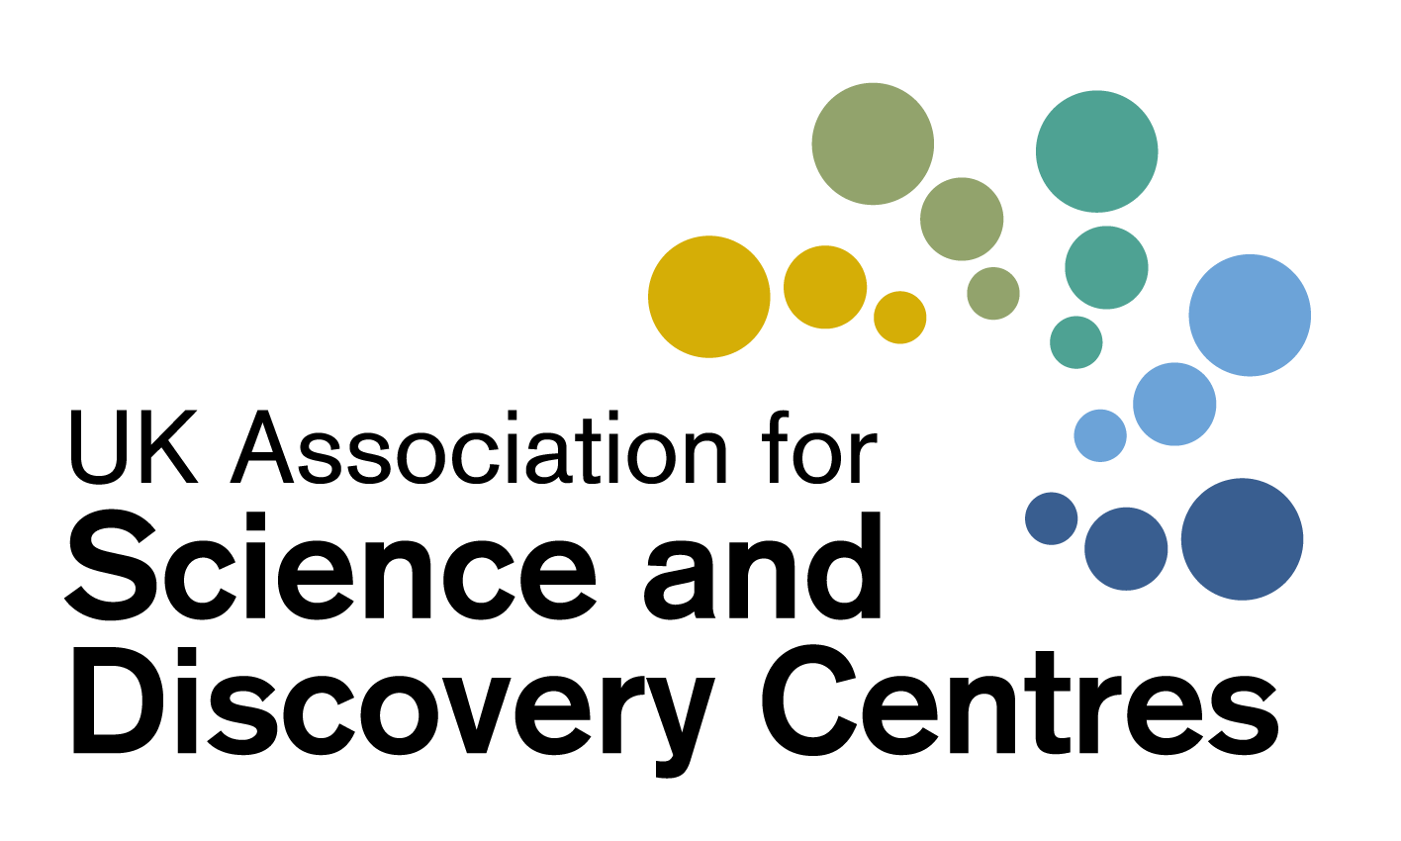

Treasurer’s report

ASDC AGM November 2019

Annual Accounts for 2018-19
The accounts are detailed in the ASDC Accounts 2018-19 from page 14 onwards.

Financial results for the year 2018-19
Total income for the year was £441,774. This is a reduction from 2017-18 (£585,824). Income from projects was down to £357,678 (from £529,161 in 2017-18). Membership fees of £32,580 are up on 2017-18 (£28,200).

A summary of income during the past four years is shown below.

Income
 | 2015-16 | 2016-17 | 2017-18 | 2018-19
Project Income | 947,704 | 748,325 | 529,161 | 357,678
Subscriptions | 28,486 | 26,450 | 28,200 | 32,580
Other income (including annual conference) | 18,475 | 22,628 | 28,463 | 51,516
Interest received | 398 | 490 | - | -
Total Income | £995,063 | £797,893 | £585,824 | £441,774

Expenditure for the year was £444,304 (2017-18: £630,308). General costs (cost of provision of services) have reduced to £267,336 (from £284,041). This is largely due to the reduction in irrecoverable VAT. Most overhead costs have remained steady.

A summary of the expenditure is shown below.

Expenditure
 | 2015-16 | 2016-17 | 2017-18 | 2018-19
External costs of projects | 588,292 | 578,893 | 346,267 | 175,768
Cost of provision of services | 194,287 | 231,171 | 282,841 | 267,336
Governance costs | 1,200 | 1,200 | 1,200 | 1,200
Total Expenditure | £783,779 | £811,264 | £630,308 | £444,304

The organisation shows a small deficit of £2,530 during the year against a deficit of £44,484
in 2017-18.

The following table shows the breakdown of reserves for the past five years.

Reserves
 | 2014-15 | 2015-16 | 2016-17 | 2017-18 | 2018-19
Income | 305,750 | 995,063 | 797,893 | 585,824 | 441,774
Expenditure | 272,704 | 783,779 | 811,264 | 630,308 | 444,304
Surplus /deficit | £33,046 | £211,284 | (£13,371) | (44,484) | (2,530)
ASDC reserves | £161,354 | £372,638 | £359,267 | £314,783 | *£312,253
* As detailed in the full accounts the total reserves figure is all unrestricted reserves

Financial overview
As in previous years, the income from projects has been a large percentage of the total income with ASDC continuing to be successful in securing funding for National STEM Programmes. At the end of the financial year only three projects were continuing into the new financial year, following completion of several towards the end of the financial year under review, including both EU projects that the organisation was involved with.

The organisation continues to maintain a reasonable balance of unrestricted reserves.

The Board regularly monitors the level of uncommitted reserves to ensure that the organisation can continue to operate effectively for the foreseeable future.

Thanks
Thanks are due to Corrigan Associates for carrying out the independent examination of the accounts and to Penny and her team for their continuing provision of services to members within tight financial constraints.

Examination of accounts
The annual income of ASDC falls within the levels at which full audit is not required. Provision is made in law for small and medium charities to use an intermediate method of scrutiny known as an independent examination.

Conclusion
We recommend that the accounts are accepted and submitted to Companies House and the Charity Commission.

Chris Godden FCA, ASDC Finance Director
Liz Hodge, Treasurer
November 2019

