The Millennium Science Centres
2020 marks the 20th anniversary of the Millennium, a time that saw unprecedented investment from The Millennium Commission and other local and national partners to create flagship Science Centres across our nation. For 20 years these have operated as successful independent and locally-focussed businesses and charities, stimulating curiosity and interest in science, bringing the most exciting and latest science to children and families where they live, and doing so in an equitable manner that appeals widely and allows people of all backgrounds to start to explore and investigate.
The host of new ‘Millennium Science Centres’ were also instrumental in kick-starting and delivering major new urban regeneration programmes which have seen the areas in which they operate turn from unused waste-land to lively buzzing urban centres, attracting considerable inward investment. Within this document we include an analysis of which centres were funded through Millennium Commission funding and then ISF funding, along with an analysis of how many UK centres would be eligible to apply for this new grant programme. This is instrumental in setting the number of grants.
The following information is a summary of which UK Science Centres were already in operation before this time, which were awarded Millennium Commission funding, where they are located and when they opened.

Before the Millennium
Before 2000 there were a number of successful charitable Science Centres in operation across the UK. Some of these are recipients of investment through the Inspiring Science Fund.
Those in operation before 2000 include, for example, the following charitable organisations (those with a * now have ISF funding):
- Techniquest, Cardiff*
- Catalyst in Widnes*
- Eureka! The National Children’s Museum in Halifax*
- Aberdeen Science Centre (formerly Satrosphere)*
- Centre for Alternative Technology in West Wales
- The Observatory Science Centre in Sussex

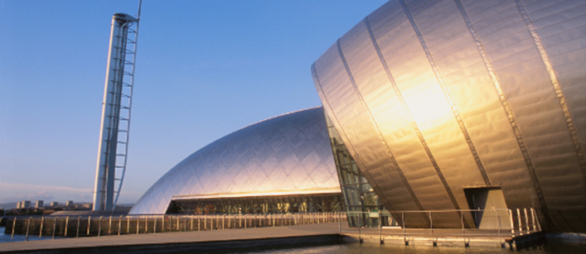
The Millennium Commission investment in Science Centres

The Millennium Commission invested over £250 million in building new Science Centres in the UK.
The Millennium Commission was established in 1994 to distribute National Lottery money to assist communities in marking the close of the second millennium and the start of the third. Overall, The Millennium Commission invested around £2 billion across the UK in capital projects, festivals, buildings, environmental projects, celebrations and community schemes and the Dome.
There were three strategic criteria across all the Millennium Commission's capital awards:
The projects had to be:
- Of all sizes
- Spread across the country
- Accessible to all sectors of the community.
As a result of this last point, many of the new Science Centres were set up in areas not traditionally associated with tourism, and had urban regeneration as a central focus.
Rather than proposing themes for capital projects, the Millennium Commission invited bids for funding in four bidding rounds. Successful bids fell into five areas:
  - Science and technology
  - The environment
  - Education
  - Communities
  - Regeneration
Of all the millennium projects, one in five (20%) had a science or technology element.
In total, over £250 million was awarded to 14 Science Centres and two botanic gardens, with the money restricted for capital costs. The Science Centres were required to contribute 50% partnership funding and be self-supporting into the future.

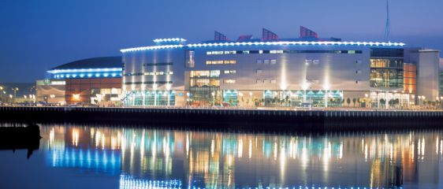
Which Science Centres are Millenium Centres?

The following charitable Science Centres were set up at the Millennium. They were created with a mix of investment, including a substantial grant from the Millennium Commission and are therefore known as Millennium Commission centres. Many were urban regeneration projects and some (e.g. W5 and Thinktank) were within larger city redevelopments housing other community facilities. All 11 are members of ASDC.
Science and Discovery Centres
- Millennium Point, Birmingham (Thinktank)
- Dundee Science Centre
- The Odyssey, Belfast (W5)
- At-Bristol
- Glasgow Science Centre
- The International Centre for Life, Newcastle
- National Space Science Centre, Leicester
- Magna, Rotherham
- Our Dynamic Earth, Edinburgh
- Winchester Science Centre (formerly INTECH 2000), Hampshire
- The Eden Project, Cornwall

Botanic Gardens and Aquaria
- The Deep, Kingston upon Hull
- The Scottish Seabird Centre
- Millennium Seed Bank, Sussex
- National Botanic Garden of Wales

ReDiscover
Often you will see additional centres being talked about as having had Millennium Commission funding. This however does not mean they were set up with a funding mix that included investment from the Millennium Commission, but rather they were awarded smaller grants through ReDiscover. This was a later and separate round of funding for science centres in 2002-3, which was a joint venture between the Wellcome Trust, the Wolfson Foundation and the Millennium Commission.

The Wellcome Trust contribution to the Millenium Centres
The Wellcome Trust awarded £37 million to seven Millennium Science Centres (Ref: Parliamentary Office of Science and Technology).
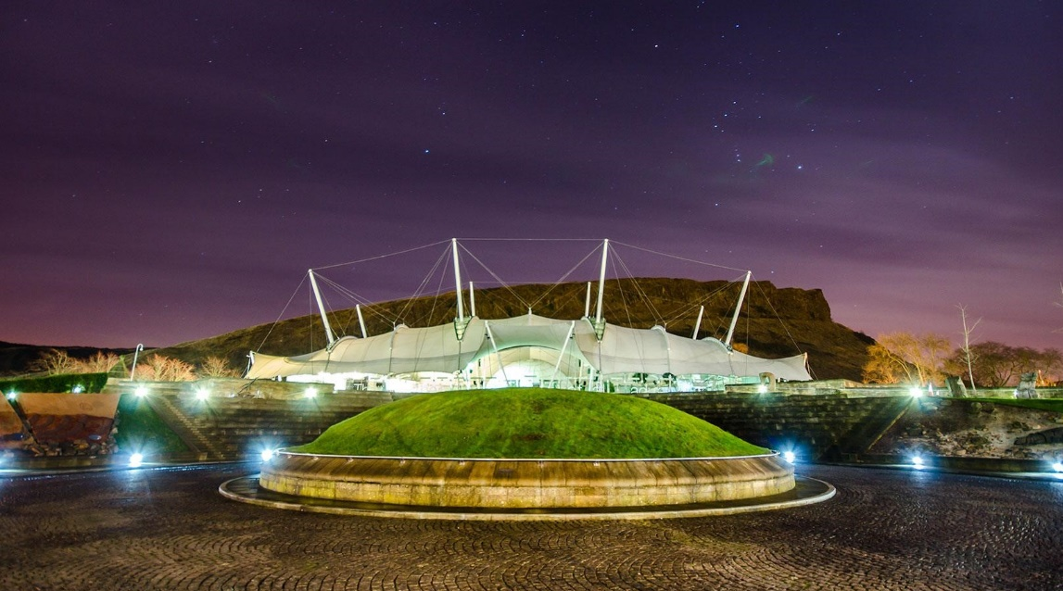
Wellcome were also (as above) part of ReDiscover in 2002-3, a £33 million fund provided by the Millennium Commission, the Wellcome Trust and the Wolfson Foundation. Museums and many Science Centres were able to compete for this fund.

Millennium Science Centre Opening Dates and 20th anniversaries
The Millennium Science Centres across the UK opened between 1999 and 2002, depending on which round of funding they were part of, their partnerships and their local needs. They therefore have a range of 20th anniversary dates spread across three years (2019 – 2022).
For example, The Centre for Life in Newcastle opened in 2000 and they have a series of celebratory and birthday events in their programme for their 20th anniversary in 2020. Winchester Science Centre opened in 2002 and have 20th anniversary activities in their diaries for 2022.
The UK science centre sector, and the ASDC network that brings the centres together, is often viewed as a world-leader. We are the largest and most active European national network of science centres and we are very much part of the European Science Centre networks meetings. We also collaborate closely with the American Association of Science and Technology Centers (ASTC), and other continental networks such as the Asian and South American Networks.

Summary by Dr Penny fidler, April 2020

Map of The UK Science Centres that had some Millennium Commission investment for their initial build.
