Request to allow charity employees to continue working on furlough

Dear <insert title & name>,

I am writing to request a change to the rules regarding furlough and charities, to allow charity employees to continue working on their charitable mission whilst on furlough. I am the CEO of We The Curious, an educational science centre in Bristol. As a registered charity, we inspire and inform half-a-million visitors a year about the importance of science in our modern world and encourage them to participate in the scientific process. We are a vibrant part of Bristol’s cultural landscape and work with disadvantaged communities, schools and academia. As a member of the UK network of science centres we contribute to engaging and educating 20 million people with science annually, across our nation.

We have closed our public venue due to the Coronavirus crisis, but our work to engage people with contemporary scientific issues has never been more critical. Our work is now focussed on rapidly creating interactive content to engage audiences, school pupils and teachers with science online, whilst developing programmes on how science can help with future challenges. However, our public venue provided the revenue for our charity, and now it is closed we are left without income and our cash reserves will soon be depleted. As such we have turned to the furlough scheme to continue paying our staff and increase our longevity.

As grateful as we were to see the government’s furlough scheme introduced, it has left us with an impossible dilemma. If we furlough our staff to protect our future, then they must halt work on delivering our charitable mission. Conversely, if we continue working to deliver our mission for public good, then our dwindling reserves will soon run out and we will cease to exist. Therefore, we are simply asking for a change to the rules on furlough, to permit charity employees to continue working for that charity whilst their pay is supported by the furlough scheme.

The furlough scheme was introduced to allow organisations to survive and to keep their staff employed. For commercial organisations it makes sense that they should not be making money whilst subsidised by the government. But for charities, whilst furlough is supporting their salaries, their work has ceased and the essential social benefit of charities across the nation is brought to a halt. If charity employees were still allowed to work whilst on furlough, then they would be financially supported and their public good would continue, at a time when they are more needed than ever. Coronavirus has made charities extremely vulnerable as they struggle to pay their staff, yet they are key to social resilience in this crisis. Therefore, having charity staff across the country still serving their communities whilst on furlough is the perfect solution.

Our charitable objectives have never been more vital to society. We must continue working with our audiences online to promote the role of science in saving and improving lives during this crisis, whilst continuing to inspire the next generation of scientists to create a resilient future for all. The absolute necessity of science in our modern world has never been more apparent. With the right support we can continue to engage people in that conversation, now, and for many years to come.

Our plea is for the government to make this simple change to the furlough rules. It would cost no additional money, as staff are already on furlough, but it would unlock a great resource for social good, which is currently suspended as the nation’s charity staff are forced to sit idle during this crisis.

Yours sincerely,

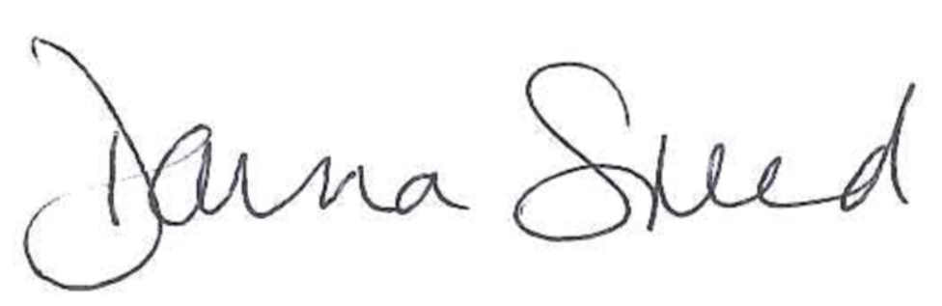

Donna Speed
Chief Executive Officer, We The Curious

One Millennium Square, Harbourside, Bristol, BS1 5DB
07967 334 146 donna.speed@wethecurious.org

