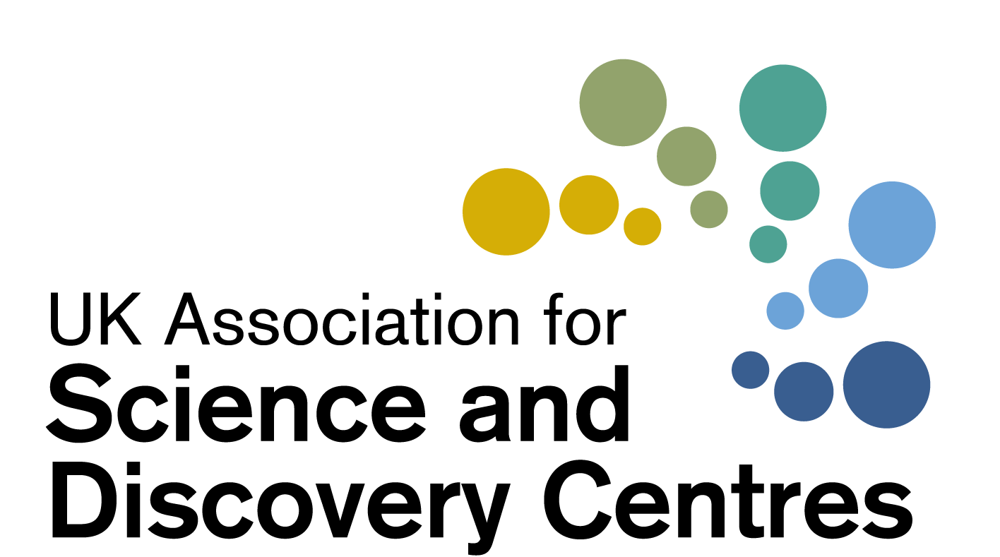

UK Science Centres: Key points and information
June 9th 2020, by Dr Penny Fidler, CEO of ASDC

The UK’s Science Centres open up science, making it accessible for everyone. They find new ways to inspire people with the latest science and ignite curiosity about the world around us.
They engage millions of children and adults every year in towns and cities across our country.
They cover all areas of science, from climate and environment to health, physics and space science.

Science centres are:
- Well run successful charities.
- Entrepreneurial and innovative.
- They earn their incomes from family ticket sales, schools paying for specialist STEM workshops, Inspirational STEM programmes, science events, weddings, industry events, subsidiary businesses, shops and cafes and fundraising.
- These income streams fund the charitable mission of making science accessible to all across their communities.
- Science Centres are currently closed, and their income is cut off. Alongside this they have had cancellations of most future big event hire bookings and school bookings until next year.
- They specialise in future-focussed science, and hands-on science, and their popularity is precisely because the science is hands-on, interactive and fun. This hands-on factor means there will be additional challenges in re-opening.

Science Centre’s Supporting Growth to 2.4% in Science R&D
- We were all delighted to see the increased investment in Science R&D in the March Budget, and welcomed the ambitious plans of putting research and innovation at the heart of the Government’s Industrial Strategy.
- As charities with a mission to inspire young people and communities with STEM, we were truly delighted to see the brilliant commitment to increase the total R&D expenditure to 2.4% of GDP by 2027.
- To achieve this, and subsequently sustain these levels, we need to grow the STEM workforce.
- Science Centres exist to inspire people with the wonders of science and the world around them, to open up access to science to many who didn’t know they would have an interest, and Science Centres have programmes to inspire careers in all areas of science.
- For example, in just Phase 1 & 2 of our National Physics and Engineering Programme with STFC, 347,000 children and adults took part and 45,852 met and spoke with a scientist or engineer. In the large-scale external academic evaluation of this programme, children said it made them more interested in working in science, and there was no difference between genders in terms of interest and engagement with the physics and engineering we shared.
- We also note that the 11-year olds now in our inspirational science workshops are the entry level STEM workforce in 2027.
- The 14-year olds currently meeting satellite engineers and taking part in space workshops at Science Centres, are the degree qualified STEM graduates in 2027.

Creating a more diverse STEM workforce and equitable society
Equity and diversity are key drivers for Science Centres. We strive on a daily basis to unlock science, open it up and make it relevant and accessible to children and adults of all genders, abilities and backgrounds. Through all our special programmes it is at the heart of all we do. Our regional Science Centres in England, Northern Ireland, Scotland and Wales aim to Level up, reducing regional and local disparities through education and STEM. ASDC and the Science Centres have a number of programmes addressing inclusion in STEM. It would be such a shame to loose all this, at this point.
We know Science Centres reach widely and have broad appeal.
- Destination Space, ASDC’s national STEM programme with the UK Space Agency, had over 900,000 participants in space workshops and events
- (Or 2.1 million participants if we include those visiting our programmes exhibitions)
- The large-scale independent academic evaluation of 12,000 students showed that more children from disadvantaged schools visited than from other schools. (23% of children were from schools on the top 20% of the indices of multiple deprivation).
- Science Centres taking part in ASDC’s national STEM programme ‘Explore Your Universe’ and other programmes, work in depth with youth and community partners within the most socio-economically disadvantaged regions of the UK.

Climate, COP 26 and Striving for Net Zero
As a nation and as a global society we have some major challenges ahead, especially in relation to climate. To solve these challenges, we need an entrepreneurial and scientifically engaged society and sufficient interest from young people in pursuing careers in green innovation. Science Centres unlock science for people locally, making it accessible and interesting to millions of children and adults each year. Before Coronavirus, millions of children and adults were taking part in environment programmes at Science Centres, with centres striving for net zero. 200,000 people recently took part in ASDC’s national programme funded by NERC to use new ways to engage families with the latest environmental science.

The UK National Network: The data
The national network is made up of a huge range of Science Centres, Science Museums, learned societies, and environmental Science Centres, large and small, rural and city centre, in all four nations.
- The whole UK network of around 60 Science Centres and museums welcomed over 25 million people each year.
- The Science Centres (when we exclude the DCMS-funded museums) reach over 11 million children and adults each year. Funding is generally from a mix of sources individual to that centre.
- Approximately 20% of visits to Science Centres are schools classes for specialist STEM workshops booked by their teachers. For some centres this rises to over half.
- Approximately half of all participants are school-age children.
- Approximately half of all participants in Science Centre programmes are girls and women.

Financial information
All of this is at Risk
- These are orderly charities
- The risk is very real

They have told us (Based on information they had on June 4)
- When they re-open, their maximum capacity to allow for social distancing will be 30-40% of capacity.
- 96% of Science Centres have told us they will not be able to cover costs when they open at 30%.

- Together they estimate their income will be reduced by around £90 million in this financial year as compared to the last year pre-Covid (note this is an estimate across all centres, and financial year ends vary between centres).

- 25% have told us that even using everything at their disposal now and in the future, their charitable STEM centre will cease to be a going concern within the next 6 months.
- 42% said they will cease to be a going concern within the next 12 months.
- In total, 67% of Science Centres tell us they will cease to be a going concern in the next 18 months, or are still doing the latest modelling. This is of a sample of 25 centres.
- For some smaller centres £200,000 would save them and set them off on a sustainable footing. For larger centres, the need is larger.

Redundancies
- 19% are making redundancies within 1 month (data given on June 5)
- 65% are making redundancies in 1-3 months
- 90% are making redundancies in 1-6 months (cumulative)
- The first redundancies will be the education teams, and diversity, inclusion and communities teams, hollowing out their key charitable STEM mission.

In summary
- We need the UK’s world-leading Science Centres to be here in 6-18 months.
- Science has never been so important, and will be crucial for the UK’s recovery from this pandemic. It would be such a shame to lose this vital sector over the next 18 months.
- An investment £25 million would protect the loss of the UK’s Science Centres, so they can continue to inspire families, schools and our communities with science for the future.

