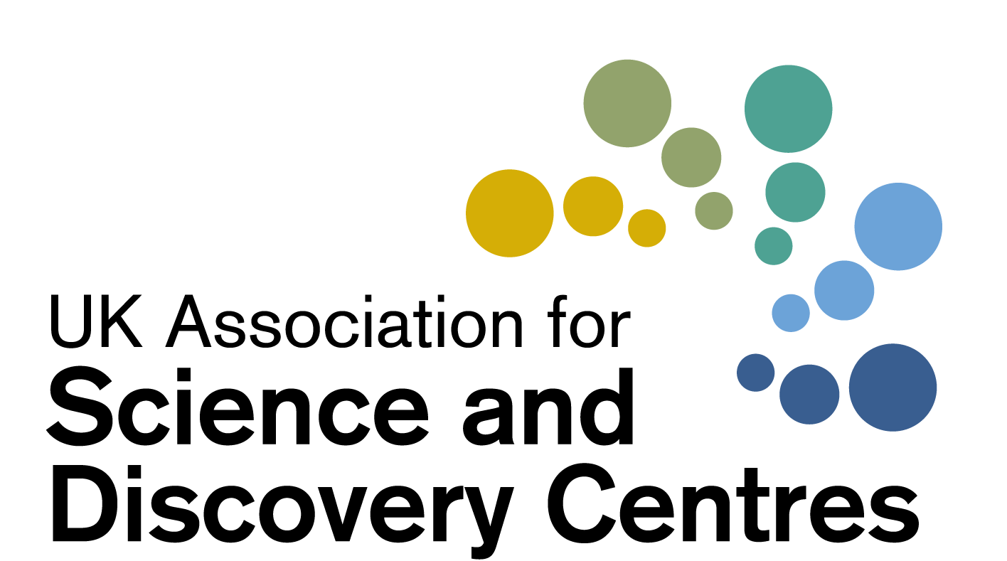

Science Centre Resilience Forum:

Levelling up: Inspiring Schoolchildren and Teachers during the pandemic
Wednesday 10th February 2021
2pm – 3.15pm
Chaired by Dr Penny Fidler, CEO of ASDC

 | Agenda for Discussions
2pm | Welcome to participants by CEO Dr Penny Fidler  What can we do more of to help Schools, Schoolchildren and Teachers | Dr Penny Fidler
 | Engaging Schools: Playing to your strengths and choosing what to adapt | Science Oxford
 | - The value of a strategic plan in a time of change  - Adapting outreach and visits  - Choosing what to do online, and how far to go  - Digital support for school-led engagement | Bridget Holligan,  Director of Education and Engagement  And ASDC Trustee
 | Digital divide, What STEM got to do with it? | Aberdeen Science Centre
 | - Different modes of engagement that we tried at Aberdeen  - How we are trying to conquer the ‘digital divide’ and ‘digital fatigue’  - How we are trying to support schools and communities in the future | Konstantinos Minas, Community Engagement Manager
 | Innovation with Schools: Sharing ideas and examples
 | - How are Science Centres working with ASDC through our Projects inspiring Schoolchildren.  - What are other centres doing? | ASDC team  Participants to input
 | Quick discussion: Business interruption Insurance
 | - Supreme Court judgment in FCA (Financial Conduct Authority) business interruption insurance test case  - Anyone had a success yet? | For Discussion
 | Quick Briefing: ASDC Grants and other opportunities | All to share
 | - Project Inspire: ASDC’s new Digital Innovation Fund and Leadership Programme for Science Centres  - List of grant successes from DCMS awards (Arts council, NLHF) | Penny Fidler  Shaaron Leverment,  ASDC Deputy
- ONS: Perceptions of the future
- NHS Test and Trace
 | Next meeting – what topics do you want to discuss? Re-opening plans?
3.15 | Close
Please arrive with questions and examples to share with colleagues
Wishing you and your teams well at this time

Perceptions of the Future.

The ONS’s latest survey on the social impacts of coronavirus and perceptions of the future has found that:

The proportion of adults in Great Britain that felt that life will return to normal in six months or less continued to gradually fall, now at 17% compared with 20% last week.

The proportion of adults who felt that it would take more than a year for life to return to normal continued to gradually rise. Just under 3 in 10 (29%) of adults felt it will take more than a year for life to return to normal, compared with 28% last week.

Around a third (33%) of adults felt that it would take between seven months and a year for life to return to normal, a slight decrease from 35% last week.

https://www.ons.gov.uk/peoplepopulationandcommunity/healthandsocialcare/healthandwellbeing/bulletins/coronavirusandthesocialimpactsongreatbritain/5february2021

NHS Test and Trace portal for employers.

NHS Test and Trace have launched a new portal for employers with a headcount of 50+ that require their staff to attend their place of work (rather than work remotely) to request rapid lateral flow tests for their organisation: https://www.gov.uk/get-workplace-coronavirus-tests

FCA’s business interruption insurance test case: Supreme Court Judgement
The Supreme Court has delivered its judgment in the Financial Conduct Authority’s (FCA)’s business interruption insurance test case. (15 Jan 2021) https://www.fca.org.uk/news/press-releases/supreme-court-judgment-business-interruption-insurance-test-case
370,000 policyholders were identified as holding 700 types of policies issued by 60 insurers that may be affected by the outcome of the test case. Many have previously been told they cannot claim.

Dear CEO Letter (from the FCA)
https://www.fca.org.uk/publication/correspondence/dear-ceo-letter-business-interruption-insurance-january-2021.pdf

Culture Recovery Fund for Heritage: Second Round | The National Lottery Heritage Fund
Who was awarded the DCMS funding?
- https://www.artscouncil.org.uk/publication/culture-recovery-fund-data
- https://historicengland.org.uk/whats-new/news/more-lifeline-grants-for-culture/
- https://www.gov.uk/government/news/lifeline-grants-for-culture-in-all-corners-of-the-country

Links shared during the meeting (added after by Cait Campbell)

- Thinking, Doing, talking Science (TDTS), Bridget Holligan: https://www.tandfonline.com/eprint/V4MEAJ6EQPTDTMSAFRAH/full?target=10.1080/09500693.2020.1821931
- Think, Doing, Talking Science website: https://tdts.org.uk/
- A clip from ASDC’s Bridging the Digital Divide event of Andy from Science Oxford Discussing their Big Science at home event: https://youtu.be/IMeGXMTdtMA
- The Big Science Event, Science Oxford: https://scienceoxford.com/big-science-event-at-school/
- Science Oxford Digital Resources: https://scienceoxford.com/resources/
- CLD Course which Kostas Minas talked about: https://www.udemy.com/course/science-for-community-learning-and-development-workers/
- RAiSE Scotland: https://twitter.com/RaiseScotland/status/1336976189127340033?s=20
- The National Tutoring Programme: https://educationendowmentfoundation.org.uk/covid-19-resources/national-tutoring-programme/

