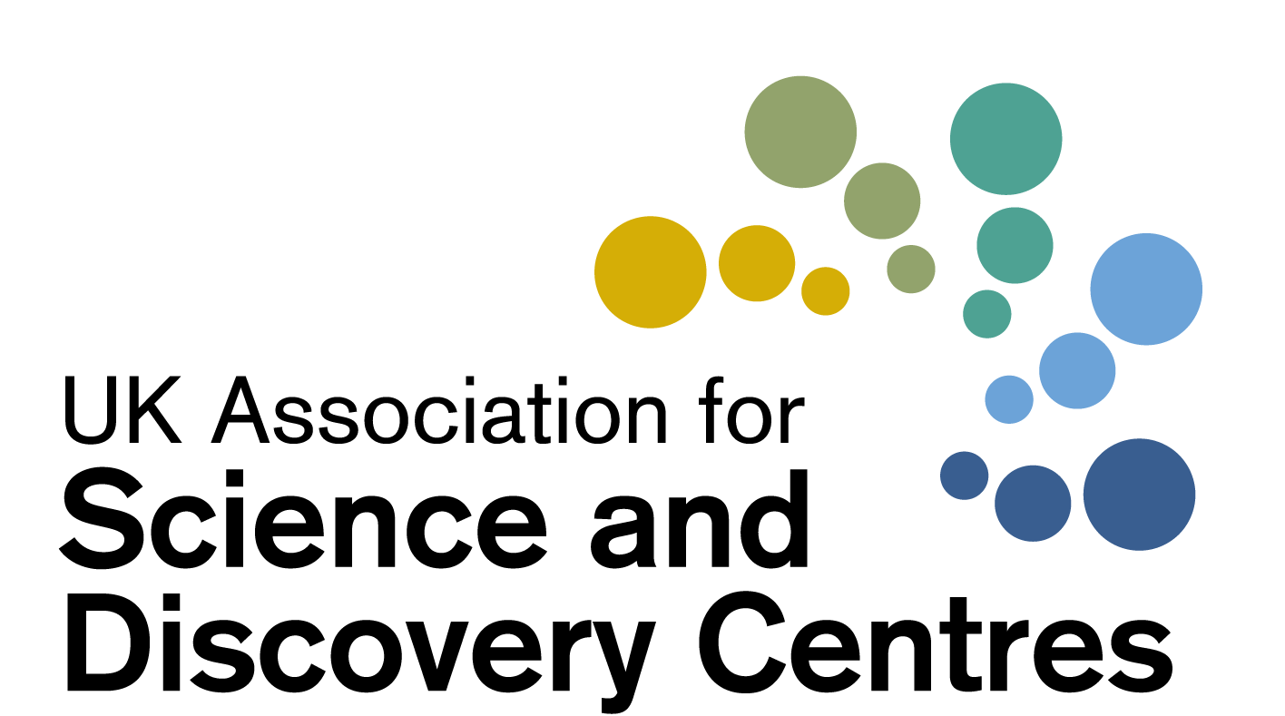

Science Centre Resilience Forum:
Innovation in UK Science Centres
Wednesday 27th January 2020
2pm – 3.15pm
Chaired by Dr Penny Fidler, CEO of ASDC

 | Agenda for Discussions
2pm | Welcome to participants by CEO Dr Penny Fidler | Dr Penny Fidler
 | Using a Science Centre as a Covid centre, community support and food bank | W5, Belfast
 | - Using our Car Park as a Covid Centre  - Using our Spaces to support our community and Food Bank  - Locked up buildings. What we have learnt the hard way  - Thinking differently for a fully digital approach for the NI Science Festival | Judith Harvey, Head of Education and Public Affairs  W5 Science Centre & Odyssey Trust
 | Innovations due to Covid that our Centre will continue | Eureka! Halifax
 | - New Practices around Operations - What we’ve all learnt?  - What are the challenges going forward? E.g. Opening with fewer staff  - How do we collate and share our new ways of working? | Tudor Gwynn  Operations and Projects Director, Eureka! The National Children’s Museum
 | Some other examples of innovation
 | - Using Science Centres as Vaccination Centres  - Working with Young Carer groups and Food banks  - Others from Centres around the UK? | Dr Penny Fidler and others  All to input
 | Supreme Court Ruling on Business interruption Insurance
 | - Supreme Court judgment in FCA (Financial Conduct Authority) business interruption insurance test case  - Can you claim?  - Dear CEO letter | Introduced by Dr Penny Fidler,  For Discussion
 | Quick Briefing: Grant and other opportunities in January
 | Project Inspire: ASDC’s new Digital Innovation Fund for Science Centres  - ASDC’s Digital innovation Programme - Deadline Friday Jan 29th  - ASDC Leadership Programme – led by Shaaron | Penny Fidler  Shaaron Leverment,  ASDC Deputy
 | List of grant successes from DCMS awards (Arts council, NLHF)
3.15 | Close
Wishing you and your teams well at this time

FCA’s business interruption insurance test case: Supreme Court Judgement
The Supreme Court has delivered its judgment in the Financial Conduct Authority’s (FCA)’s business interruption insurance test case. (15 Jan 2021)
The Supreme Court has substantially allowed the FCA’s appeal on behalf of policyholders. This completes the legal process for impacted policies and means that many thousands of policyholders will now have their claims for coronavirus-related business interruption losses paid.
https://www.fca.org.uk/news/press-releases/supreme-court-judgment-business-interruption-insurance-test-case
370,000 policyholders were identified as holding 700 types of policies issued by 60 insurers that may be affected by the outcome of the test case. Many have previously been told they cannot claim.

Dear CEO Letter (from the FCA)
https://www.fca.org.uk/publication/correspondence/dear-ceo-letter-business-interruption-insurance-january-2021.pdf
“It remains the case that most SME BI policies are focused on property damage and only have basic cover for BI as a consequence of property damage, so are unlikely to pay out in relation to the Covid-19 pandemic and its effects. However, some policies providing cover for BI from other causes, in particular infectious or notifiable diseases and non-damage denial of access and public authority closures or restrictions, do provide cover for these events.
We believe the Court judgments in the test case give all insurers the clarity they need to now conclude their claims processes with the large majority of their BI customers. We encourage all insurers to do so as quickly as possible. In some cases the judgment will mean that previously rejected claims (and complaints) are now valid or that the value of customers’ valid claims will have changed. We expect you to be clear on these points and on your next steps as you write to all your policyholders with affected claims or complaints over the coming week.”

Culture Recovery Fund for Heritage: Second Round | The National Lottery Heritage Fund

Who was awarded the DCMS funding?
- https://www.artscouncil.org.uk/publication/culture-recovery-fund-data
- https://historicengland.org.uk/whats-new/news/more-lifeline-grants-for-culture/
- https://www.gov.uk/government/news/lifeline-grants-for-culture-in-all-corners-of-the-country

Links shared during the meeting (added afterwards by Cait Campbell)

- NI Science Festival: https://nisciencefestival.com/
- Northumberland Dark Sky Festival: https://www.eventbrite.co.uk/o/astroventures-cic-7582255843?aff=eand
- Project INSPIRE Ideation session: https://youtu.be/HEMX0IUVV4c

