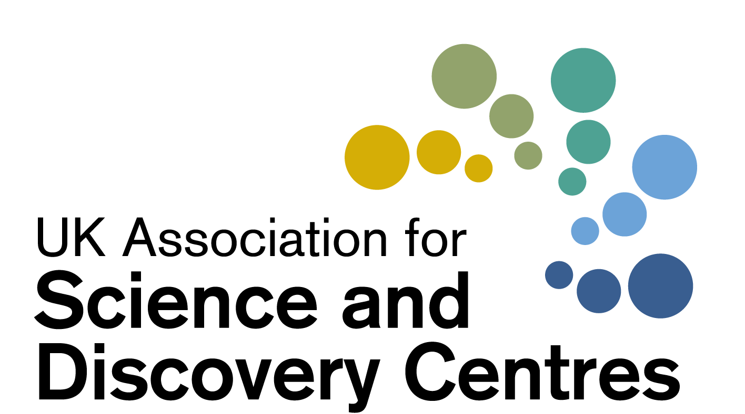

Coronavirus Resilience Forum
for UK Science Centres
Wednesday 13th January 2020
2pm – 3.15pm
Chaired by Dr Penny Fidler, CEO of ASDC

 | Agenda for Discussions
2pm | Welcome to participants by CEO Dr Penny Fidler | Dr Penny Fidler
 | Grant opportunities in January
 | Project Inspire  ASDC’s new Digital Innovation Fund and Leadership Programme for Science Centres  - Bidders Call Thursday Jan 14  - Ideation session and masterclasses | Penny and Shaaron
Other grant successes?
Garfield Weston? ISF?
Who has been successful with which grants?
DCMS awards (Arts council, NLHF, Scottish Government)
 | Discussion on The Cultural Recovery Fund
- The Cultural Recovery Fund 2nd Round NHLF £36 million
- Deadline 2pm on 26 January 2021
- £10,000 and £3m to support organisations to make the transition towards full re-opening.
 | Discussion Forum on the following topics and any others you wish to add
- Sharing Re-opening dates and plans

- ASDC Grant programmes and projects delivered by UK Science Centres

- New Digital Engagement by Centres, and how are we helping schools?

- Any other discussion topics

3pm | Using Science Centres as Vaccination Centres | Linda Conlon  Centre for Life
3.15pm | Close
Wishing you and your teams well at this time

Culture Recovery Fund for Heritage: Second Round | The National Lottery Heritage Fund

Who was awarded the DCMS funding?
- https://www.artscouncil.org.uk/publication/culture-recovery-fund-data
- https://historicengland.org.uk/whats-new/news/more-lifeline-grants-for-culture/
- https://www.gov.uk/government/news/lifeline-grants-for-culture-in-all-corners-of-the-country

