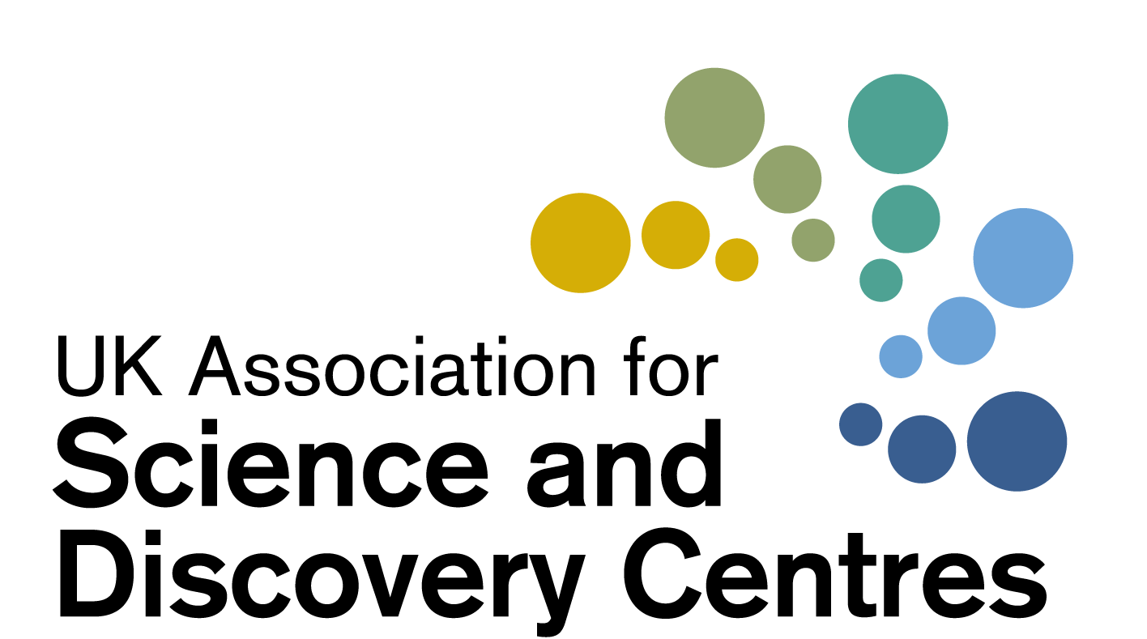

Science Centre Resilience Forum

Visitor Perception and Confidence

Information and strategies for your Re-opening
Wednesday 24th February 2021
2pm – 3.15pm
Chaired by Dr Penny Fidler, CEO of ASDC

 | Agenda for Discussions
2pm | Welcome to participants by CEO Dr Penny Fidler  What do we know about Visitor Perception and Confidence? How has Monday’s Roadmap affected your business planning? | Dr Penny Fidler
 | Audience Perception and Confidence: What does the latest UK-wide Research tell us to inform re-opening strategies
 | - The public sentiment research – what are the public currently saying about visiting attractions after the lockdown?  - The Visitor Recovery Benchmarking Survey  - How joining this benchmarking study might benefit your own Science Centre or Museum | Guest Speaker  Steve Mills, Director  Decision House  www.decisionhouse.co.uk
 | Info from PMs announcement on Monday 22 February
 | - Museums and Science Centres across England can reopen from 17th May ‘at the earliest’, in step three of the strategy.  - From 12th April: Second phase - Shops and outdoor hospitality including retail, zoos, theme parks and ‘public buildings such as libraries and community centres’ can re-open. | Introduced by Penny Fidler  Sharing re-opening plans and strategies  Details on next page
 | Quick highlight: ONS: Perceptions of the future
 | Coronavirus and the social impacts on Great Britain - Office for National Statistics (ons.gov.uk) | Details on next page
 | Quick discussion: Business interruption Insurance
 | - Business interruption insurance following Supreme Court ruling for Financial Conduct Authority  - Anyone had a success yet? | Details on next page
 | Other notices and announcements
 | Next meeting – what topics do you want to discuss?
3.15 | Close
Please arrive with questions and examples to share with colleagues.
Wishing you and your teams well at this time

Links shared during the call
- Lancet study: https://www.thelancet.com/journals/laninf/article/PIIS1473-3099(20)30561-2/fulltext
- Nature editorial: https://www.nature.com/articles/d41586-021-00277-8
- Summary of surface studies: https://www.theatlantic.com/ideas/archive/2021/02/hygiene-theater-still-waste/617939/
- England's Covid catch-up plan for pupils, The Guardian: https://www.theguardian.com/education/2021/feb/24/englands-secondaries-given-funding-to-run-summer-schools
- ALVA Webinars: http://bit.ly/ALVARecovery21

Other Links and Further information
https://www.gov.uk/government/speeches/pm-statement-to-the-house-of-commons-on-roadmap-for-easing-lockdown-restrictions-in-england-22-february-2021
There will be no Tier system - England will be treated as a single area
- There will be 4 steps
- There will be at least 5 weeks between each step

STEP2: 12th April; from this date, non-essential retail will reopen, as will indoor leisure centres, self-catering accommodation (but only for individuals or household groups), zoos, theme parks and drive-in cinemas, and outdoors hospitality (pubs and restaurants) – with no curfew or requirement to order a substantial meal with drinks. Wedding ceremonies and receptions for 15 people will also be allowed from this date. Libraries and community centres can open (public buildings) can open
Page 34 of the roadmap:
- The majority of outdoor settings and attractions can also reopen, including outdoor hospitality, zoos, theme parks, drive-in cinemas and drive-in performances events.
- Hospitality venues will be able to open for outdoor service, with no requirement for a substantial meal to be served alongside alcoholic drinks, and no curfew. The requirement to order, eat and drink while seated (‘table service’) will remain.
STEP 3 will begin no earlier than 17th May. Museums, Science Centres, galleries, historic houses, pubs and restaurants can re-open and indoors spaces of visitor attractions, as well as social gatherings indoors of six people or two households. Outdoors, limit 30 people. Hotels, guest houses and B&Bs will open. Pilots will begin on the use of tests to enable larger events to resume. The numbers cap for wedding receptions and ceremonies will increase to 30 from this date.
P37 of the roadmap:
- Indoor hospitality, with no requirement for a substantial meal to be served alongside alcoholic drinks, and no curfew. The requirement for table service’ will remain.
- Remaining outdoor entertainment, such as outdoor theatres and cinemas.
- Indoor entertainment, such as museums, cinemas, and children’s play areas.
- Remaining accommodation, such as hotels, hostels and B&Bs.
- Adult indoor group sports and exercise classes; and
- Some large events, including conferences, theatre and concert performances and sports events. Controlled indoor events of up to 1,000 people or 50% of a venue’s capacity, whichever is lower, will be permitted, as will outdoor events with a capacity of either 50% or 4,000 people, whichever is lower. Pilots will run as part of the Events Research Programme
Scotland, Wales, N. Ireland
In Scotland the First Minister will announce the Government’s roadmap on Tuesday.
In Wales, the next review of lockdown rules is due on 12 March.
In Northern Ireland, the current lockdown has been extended to 1st April.

Furlough
The Prime Minister said the Government wouldn’t “pull the rug out” from businesses and would continue to do “whatever it takes” to support business through the remainder of the pandemic, noting that the Chancellor would outline what this means for business support packages during the Budget next Wednesday (4th March).
This is the link to the roadmap https://assets.publishing.service.gov.uk/government/uploads/system/uploads/attachment_data/file/963491/COVID-19_Response_-_Spring_2021.pdf

Perceptions of the Future.
The ONS’s latest survey on the social impacts of coronavirus and perceptions of the future has found that: weekly updates

This week, the proportion of adults in Great Britain that felt that life will return to normal in six months or less decreased slightly, now at 20% compared with 21% last week.

The proportion of adults who felt that it will take more than a year for life to return to normal increased slightly. Nearly 3 in 10 (29%) adults felt it will take more than a year for life to return to normal, compared with 27% last week (Figure 3).

Coronavirus and the social impacts on Great Britain - Office for National Statistics (ons.gov.uk)

NHS Test and Trace portal for employers.

NHS Test and Trace have launched a new portal for employers with a headcount of 50+ that require their staff to attend their place of work (rather than work remotely) to request rapid lateral flow tests for their organisation: https://www.gov.uk/get-workplace-coronavirus-tests

FCA’s business interruption insurance test case: Supreme Court Judgement
The Supreme Court has delivered its judgment in the Financial Conduct Authority’s (FCA)’s business interruption insurance test case. (15 Jan 2021) https://www.fca.org.uk/news/press-releases/supreme-court-judgment-business-interruption-insurance-test-case
370,000 policyholders were identified as holding 700 types of policies issued by 60 insurers that may be affected by the outcome of the test case. Many have previously been told they cannot claim.

Dear CEO Letter (from the FCA)
https://www.fca.org.uk/publication/correspondence/dear-ceo-letter-business-interruption-insurance-january-2021.pdf

Culture Recovery Fund for Heritage: Second Round | The National Lottery Heritage Fund
Who was awarded the DCMS funding?
- https://www.artscouncil.org.uk/publication/culture-recovery-fund-data
- https://historicengland.org.uk/whats-new/news/more-lifeline-grants-for-culture/
- https://www.gov.uk/government/news/lifeline-grants-for-culture-in-all-corners-of-the-country

Links shared during this meeting

