A Briefing Document
on UK Science and Discovery Centres &
their importance in the national STEM agenda
19 March 2020
Dr Penny Fidler, CEO of The UK Association for Science and Discovery Centres (ASDC)

Executive Summary
Our nation’s regional Science and Discovery Centres play a crucial role in the country’s STEM success, delivering inspirational science learning to schoolchildren and families, and working in partnership with schools, teachers, universities, STEM businesses and local communities. They build STEM Skills and open up access to science in some of the most disadvantaged regions of the UK. They are regional hubs of science expertise and run thousands of curriculum-linked education workshops supporting students with the latest science ranging across Physics, Maths, Biology and Chemistry and covering topics from space science to molecular biology and from engineering to green careers.

Due to Covid-19, Science Centres have been mainly closed since last March, and had to make 50-80% of their education teams redundant to protect the longer-term survival of their charities. Just at the time when we most need our regional Science Centres - to level up, reduce inequality, help with the Educational Recovery, inspire young people from our most disadvantaged communities into science, and encourage our young people into STEM careers.

As we work to build our nation’s future and grow our innovation economy, inspiring young people with Science is vital. This is particularly important to deliver the Government’s ambitious Industrial Strategy, increasing our R&D to 2.4% of GDP. It is also critical in this year of COP26 as we, as a nation, collectively strive to address Climate Change and drive towards Net Zero.

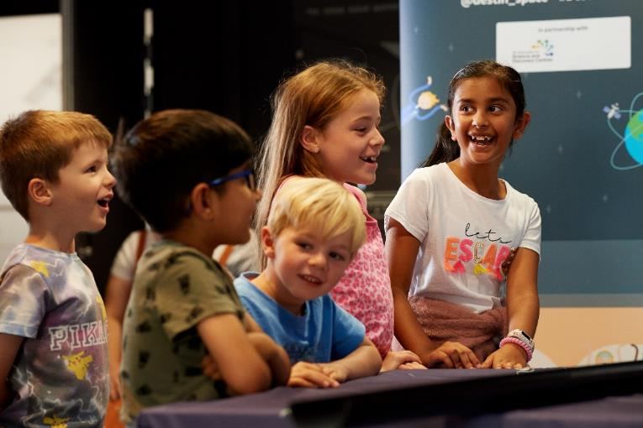

The UK Science and Discovery Centres are part of the wider ASDC network of over 50 UK Science Centres and Museums that together engage over 25 million people each year with Science. Of this network, 29 are independent Hands-on Science and Discovery Centres of which 18 are within England. The list of the regional and charitable Science Centres in each UK nation is at the end of this document and highlighted on the map. Over half those who take part at science centres are girls and women. Over half are school-age children, and around 25% come with their teachers for curriculum-linked STEM visits and targeted science workshops. They work closely with schools and families in our most disadvantaged areas.
Together, our nation’s independent, charitable future-focussed Science and Discovery Centres inspire over 5.5 million schoolchildren and their families with science every year. Their curriculum-linked STEM workshops support around 1.5 million school students with the latest science and invigorate their interest in school science. We have independent academic evidence showing that children from the UK’s most disadvantaged communities are equally engaged and interested in science through Science Centre programmes as children from more advantaged backgrounds. We also know from another large-scale academic study, that on all measures (such as interest, enjoyment and desire to study further) for our hands-on physics and engineering programmes, girls are just as inspired and interested as boys.

The Science Centres also offer a range of CPD for teachers across many subject areas from high-end physics to primary science, working in partnership to support them and their students. They also give opportunities for schoolchildren to meet young scientists and engineers. Through just one of our national STEM programmes, ASDC’s Destination Space programme funded by the UK Space Agency, 914,646 children and families took part in school workshops and space activities and 75,741 children and adults had the opportunity to meet and talk with a space scientist or engineer (half of these scientists were women). Overall, 2.1 million people explored the latest space science, including those who visited the space exhibitions created as part of this project.

Before the pandemic Science Centres saw a huge demand from schools and teachers for the innovative and exciting curriculum-linked schools workshops covering KS1 to KS4. The demand was limited by capacity (staff resource) at the science centres. The school workshops in disadvantaged communities, like the community outreach are part of the science centre’s educational charitable mission. Whilst most schools pay much of the cost of these, the remainder is covered by mission-enabling activities such as hosting corporate events, weddings etc (now cancelled) and in part by the large numbers of families who can afford to pay the entry fee visiting at weekends and holidays. This and much other charitable work is specifically what separates Science Centres from other visitor attractions.

The cost of a subsidised student visit to a science centre is around £4-£7 for all the hands-on activities in the Science Centre plus £3 for a full curriculum-linked STEM workshop on a subject the teacher chooses, although this cost varies around the country. However, we know schools now have additional costs due to covid and its impacts, making even this subsidised cost a challenge. In addition, teachers have in the past gone above and beyond to arrange visits to science centres for their students as they absolutely understand the STEM benefits both short- and long-term in motivation and learning for these students. But teachers have far more to cope with now as schools return after covid, and so whilst we are poised and ready to help, the future profile of when teachers will have extra capacity to bring the most needed students for enrichment activities at science centres is uncertain without support.

Science Centres have a major role to play in supporting the quickest recovery and the nation’s future ambitions. 2021 sees COP26 come to the UK, bringing a huge opportunity to celebrate all the green innovation and career potential for young people across the UK. We know that many young people, especially girls, are interested in being part of addressing the climate challenges and being part of the green STEM revolution and this is a fabulous opportunity we must not miss.

Science centres are entrepreneurial and earn their own incomes to operate and thrive. During the pandemic they have used all opportunities open to them, including the generous furlough scheme, loans etc. However almost all Science Centres were excluded from applying for the generous Cultural Recovery Grants totalling £1.57 billion from DCMS, unless they were situated in heritage buildings, or had a small museum within their operations.

We have so many children from disadvantaged areas falling substantially behind due to Covid, creating and entrenching inequality. Science Centres offer the opportunity to change this for the better. To help these children catch up with missed schooling in many areas and to start levelling up the longer-term damage done by the pandemic. To give children from our poorest areas a better chance in education, and in life.

UK Science Centres are supported by Scientists and UK Science
Science Centres have considerable support from UK Science, including from our Top Scientists. Over 150 high-profile science signatories, including Sir Paul Nurse, Sir Venki Ramakrishnan and six other Nobel Scientists, Astronauts Tim Peake, Helen Sharman, University Vice-chancellors, Brian Cox, Jim Al-Khalili, Lord Winston and many others have signed an open letter supporting the call for financial support for UK Science Centres, which had been excluded from applying for the generous cultural recovery grants totalling £1.57 billion for arts, music venues, theatres, cinemas and museums. This money is needed for keeping access to Science open, just as it has been for the arts. Of note, most of those denied access to these cultural grants were those created with investment of the Millennium Commission to put science at the heart of some of our most disadvantaged regional cities and culture.
The letter and 150 signatories can be viewed here https://www.sciencecentres.org.uk/projects/science-centres-our-future/open-letter/

The arrangement in Scotland and elsewhere
The arrangement in Scotland seems particularly fruitful, whereby Scottish Science Centres have an agreement with the Scottish Government to reach children in schools and support teachers and families with inspirational STEM as part of the National Science Engagement Strategy. The Scottish Government particularly wants to reach families and communities from its most deprived areas (areas high on the indices of multiple deprivation), especially now, and contracts science centres to do this for them, as they already have the relationships, the centres, the science, the activities, the means and the passion.
School science and informal science learning are best viewed as two sides of the same coin - both an essential part of the nation’s science learning strategy. We know for example that families are key influencers of children’s career choices. Indeed, in Finland with its stellar PISA results, teachers have part of their teacher training programme in a Science Centres learning all the best hands-on ways to help children experiment and become curious about the world around them and gain a passion for science and innovation. Other nation’s give one visit for each schoolchild per year to a science centre.
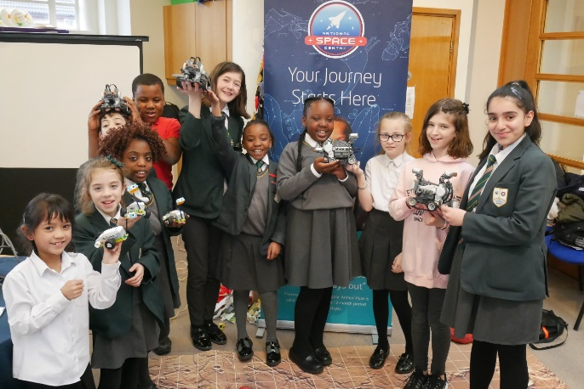
Left: A group of participants at an After School session in Leicester, based at a local library, having completed their engineering and coding activity.
Science Centres are already in place to reach under-represented schools and communities with the latest science, research and innovation. They have local, expert science engagement capability on the ground in so many places across England and the UK, and are poised to help schools and teachers recover and nurture a future generation passionate about science, the environment, research and innovation.

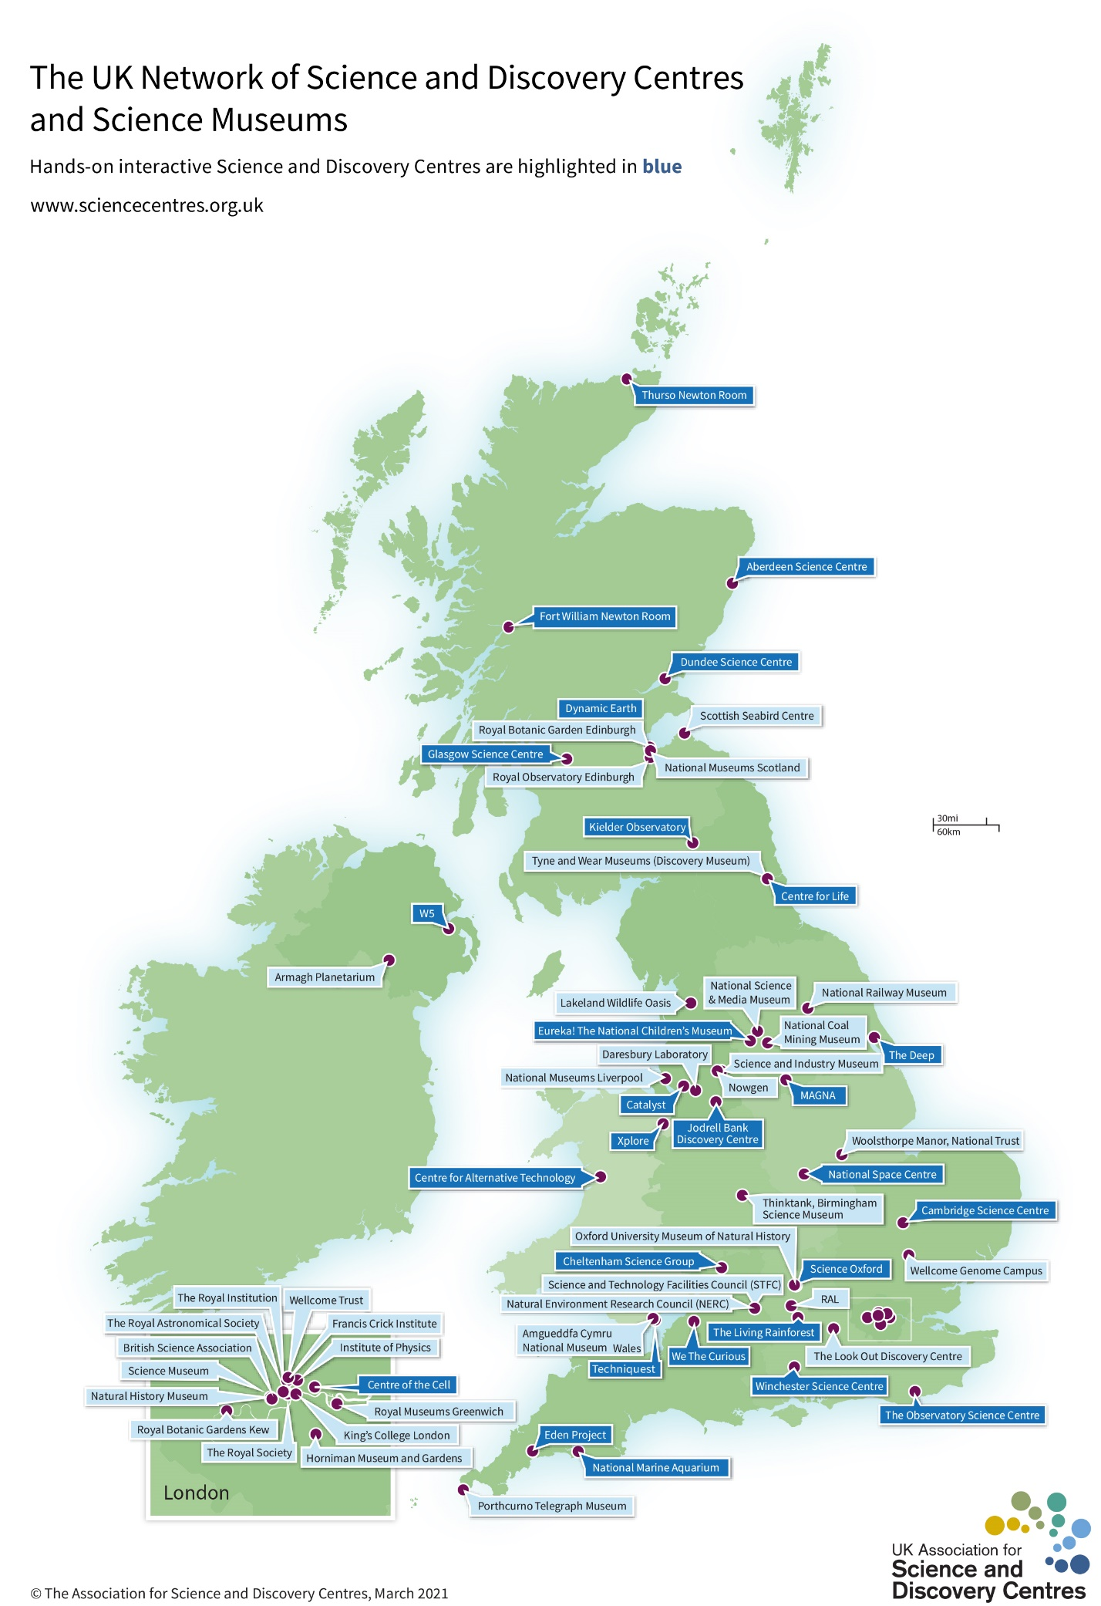Science and Discovery Centres in England, Wales, Scotland and Northern Ireland
 | Name | UK Region or City | Notes
English Science and Discovery Centres
 | Eureka! The National Children's Museum | Halifax
 | International Centre For Life | Newcastle
 | National Space Centre | Leicester
 | Kielder Observatory | Northumberland
 | Science Oxford | Oxford
 | The Deep | Hull | Millennium Aquarium
 | The Eden Project | Cornwall
 | The Observatory Science Centre | Sussex
 | The Living Rainforest | Thatcham, Berkshire
 | Centre of the Cell | London
 | Winchester Science Centre | Winchester
 | Cheltenham Science Centre (very small) | Cheltenham
 | Cambridge Science Centre | Cambridge
 | National Marine Aquarium | Plymouth | Millennium Aquarium
 | Catalyst Science Discovery Centre | Widnes | *some funds from CRF (ACE)
 | We The Curious | Bristol | *some funds from CRF (NLHF)
 | Jodrell Bank Science & Discovery Centre | Manchester | *some funds from CRF (NLHF)
 | MAGNA | Rotherham | *some funds from CRF (NLHF)
Welsh Science and Discovery Centres
 | Techniquest | Cardiff
 | Xplore! (North Wales) | Wrexham
 | Centre for Alternative Technology | Machynlleth, Mid-Wales
N. Irish Science and Discovery Centres
 | W5 (Who what when where why) | Belfast
Scottish Science and Discovery Centres
 | Aberdeen Science Centre | Aberdeen | Some funding through Scottish Government and other sources.
 | Dundee Science Centre | Dundee
 | Dynamic Earth | Edinburgh
 | Fort William Newton Room | Fort William
 | Thurso Newton Room | Thurso
 | Scottish Seabird Centre | North Berwick
 | Glasgow Science Centre | Glasgow

Twitter handles and hashtags to use to share the debate
#sciencediscovery #recovery #WestminsterHall
@sciencecentres
@DrBenSpencer and ASDC Patron @TheAliceRoberts

