Project Inspire:

A Digital Engagement and Innovation Programme for UK Science Centres

Information and Invitation to Participate

Deadline for Applications: Friday 29th January 2021

Overview
The UK Association for Science and Discovery Centres (ASDC) is delighted to announce the launch of Project Inspire in collaboration with the Inspiring Science Fund, a partnership between UK Research and Innovation (UKRI) and Wellcome.
The Vision of Project Inspire: To inspire and support UK Science Centres to engage and involve under-served communities and audiences with STEM in new and creative digital ways, and to develop new practice in emerging leadership that embraces the values of inclusivity equity and innovation.
Project Inspire is a one-year national Digital Engagement and Leadership Programme for UK Science Centres, led by ASDC. The project has two strands:
- The Digital Engagement and Innovation Programme for Science and Discovery Centres to develop new and creative digital ways to engage and involve under-served communities and audiences with STEM. This includes grants of £15,000 alongside ideation support and training.
- The ASDC Leadership Programme to nurture and support emerging Science Centre talent to become the inclusive and dynamic leaders of the future.
This Invitation to Participate relates to The Digital Engagement and Innovation Programme.

Invitation to Participate in the Digital Engagement and Innovation Programme
ASDC are seeking eight Science and Discovery Centres across the UK to partner with us for this exciting new digital inclusion programme.
ASDC has secured funding for £120,000 of Grants for your projects and we expect this will be awarded as eight Grants of £15,000. However, if your centre wishes to apply for less, or together in partnership with another centre we will be happy to consider this. Please contact us in advance to discuss.
This Programme is looking for forward-thinking Science Centres to deliver exciting digital projects that open up new ways of engaging and involving under-served and under-represented audiences. The key goal is to give Science Centres the opportunity to grow and develop their digital offer for a more diverse audience. Could this be the project that shapes the digital future of your centre?
These grants and the accompanying masterclass programme are open to publicly accessible charitable Science and Discovery Centres in the UK. You do not need to have received funding before from ISF to apply for this fund, and many of the aims in terms of inclusion are in alignment with the original ISF criteria. Further details are given in the Eligibility section.
We are seeking projects that will become examples of inspiring digital practice in community engagement within the Science Centre sector, and that can be shared with others.

Information on The Digital Engagement and Innovation Programme
The Digital Engagement and Innovation Programme is now open for applications and the deadline is January 29th 2021. The vision of this programme is to inspire and support UK Science Centres to work collaboratively with communities and audiences to develop new and creative digital ways to engage with STEM.
The programme will support UK Science Centres to explore and innovate with their communities and audiences. Using digital solutions of the widest type, this programme aims to build and enrich Informal STEM Learning in new, creative ways.
In these new times, there is an exciting opportunity with digital engagement to reach new audiences who cannot or do not normally visit Science and Discovery Centres. ASDC recognises that barriers to engaging with Science Centres may be broad and varied. This programme provides funding to better understand the needs of communities and perceptions of STEM and using that insight to build digital engagement programmes.
We are looking for forward-thinking Science Centres to deliver exciting digital projects that open up new participatory ways of engaging and involving their under-served audiences. This grant programme offers eight Science and Discovery Centres grants of £15,000 along with ideation sessions, masterclasses and peer to peer knowledge exchange, to assist them as they pilot new digital methods and work to engage their communities with science. Some will have excellent mechanisms for this already with digital teams with a great deal of experience, others will just be starting out.

The Vision of the Digital Engagement and Innovation Programme
To develop new and creative digital ways to engage and involve under-served and under-represented communities and audiences with STEM.

Programme Goals
All your proposed programme activities for The Digital Engagement and Innovation Programme should work towards delivering the programme vision.

The key goals for this national digital engagement programme are as follows:
- To inspire and support UK Science Centres to develop new participatory and innovative digital ways to collaborate with under-served and under-represented communities and audiences.
- To explore and share digital methods that are most successful in growing and broadening audience engagement across under-represented communities. In this programme we want you to play to your strengths and those of your communities.
- To collaborate with, and understand the needs of, the groups you choose to work with and to co-create content and ideas with your groups. For clarification these groups can be any community groups, including youth groups, adults, families, special interest groups or others, but not school groups.
- To create a legacy in the way Science Centres co-create and develop their digital engagement and nurture community relationships that will continue into the future.

Key audiences
The key audiences for this national programme are:
- Under-served families, adults and communities of all ages.
  - Each Science Centre is free to define the groups within their communities they wish to work in a participatory manner with, giving the rationale as to why this group is under-served and what the project will allow the Centre and community to co-create.
  - Under-served for this project includes everyone who does not or cannot generally engage with Science Centres for whatever reason, including for example for socio-economic reasons, location, children, families and adults with special needs or disabilities, people shielding, and people without English as a first language.
We know that Science Centres define under-served differently, as a guide and for the avoidance of doubt, for this project we are focussing more of people living in the most deprived 40% of UK communities as given by the Indices of Multiple Deprivation, rather than the most deprived 10%.

- Your participants and key audience can be children, families, young people and adults across all communities and ages. They can also include brownies and badged groups, youth groups and out of school clubs in relevant focussed parts of your regions, but not groups in school. These examples are given here as we know the words formal and informal mean different things to different centres.

- The programme also focusses on Science Centre staff, in particular digital managers and communications teams (including social media) working alongside Community managers in Science Centres to find new ways to engage under-served communities digitally into the future. This is what created the legacy of this project. You may also want to include staff from your exhibitions, education and IT teams or bring in external expertise and digital developers as professional development and project support.

What is on offer for participating Science and Discovery Centres
The programme will offer selected Centres the following:
- Up to £15,000 grant for your Science Centre to support your Digital Engagement and Innovation project, which may be spent on staff time and other costs. Further details are in the Grants Section below. You may apply for less if you wish.
- Three Digital Masterclasses between February and June 2021 to train two members of staff from each selected Science Centre. These will bring together expertise and speakers from selected Science Centres along with external digital engagement experts. These Masterclasses will cover a host of interactive tools, projects that have engaged communities in new ways digitally, new techniques and top tips. They will also share skills, knowledge and approaches between Science Centres that have been successful in engaging new communities during Covid-19 restrictions and find ways to use insights from digital engagement to support other parts of your audience engagement strategies.
- Ongoing support for the Science Centres from the ASDC Digital manager, including mechanisms for peer-to peer support to share best practice in engaging new communities.
- Opportunities to share expertise between Science Centres in the partnership and other national programmes, on community engagement and working with families and communities who do not currently engage.

The Grants
The grants of £15,000 may be used to contribute to staff time, digital expertise (in-house and external), funds for your community partner’s time in co-creating content and working collaboratively to design the programme, for scientist or developer involvement, software, hardware, or other costs your organisation needs to make a great success of this project.
The grant claims are on the following dates:
 | Date to invoice ASDC for Grant |  | If your grant is for £15,000
Grant payment 1 | 26 March 2021 | Paid after signature of the grant agreement | £7500
Grant payment 2 | September 30 2021 | On completion of your project, submission of your evaluation data and submission of your interim report in June and final report August 30. | £7500
Note: this is a grant. If your centre feels VAT needs to be charged then it must be within the total amount claimed. If the amount you have applied for is less than £15,000 these figures will be adjusted in proportion.

Is your Science Centre eligible to apply?
For this programme, the eligibility criteria is very similar to that of the over-arching Inspiring Science Fund (ISF). You can absolutely apply if you haven’t had a grant from this ISF before.
Science Centre’s will be eligible to apply for funding if:
- They attract a minimum of 30,000 public visitors a year (in a pre-Covid year)
- They have been in existence for at least one year
- They could apply for ISF in the past, or were funded through either round of ISF.
- They have a STEM venue that pre-Covid was accessible to the public or schools for most days of the year.
- Although the Centres do not need to be a member of the UK Association for Science and Discovery Centres, applicants will need to demonstrate how they are sharing knowledge, best practice and the latest ideas with colleagues nationally in an ongoing and effective manner.
For clarity, the following organisations and projects are not eligible to apply for this grant, unless included above:
- UK National Museums and Museums sponsored by central Government.
- Museums that pre-Covid would have been eligible to apply for capital funding from the National Lottery Heritage Fund, Arts Council England, Arts Council for Wales, Arts Council of Northern Ireland and Creative Scotland. Note, this relates to capital grants not smaller project grants from these agencies.
- Museums that can apply for funds from The Museums Association grant fund programmes.
- Zoos and aquaria which despite doing great projects, are not the target for this programme.
- Projects dedicated to engaging the public with historic collections of science.

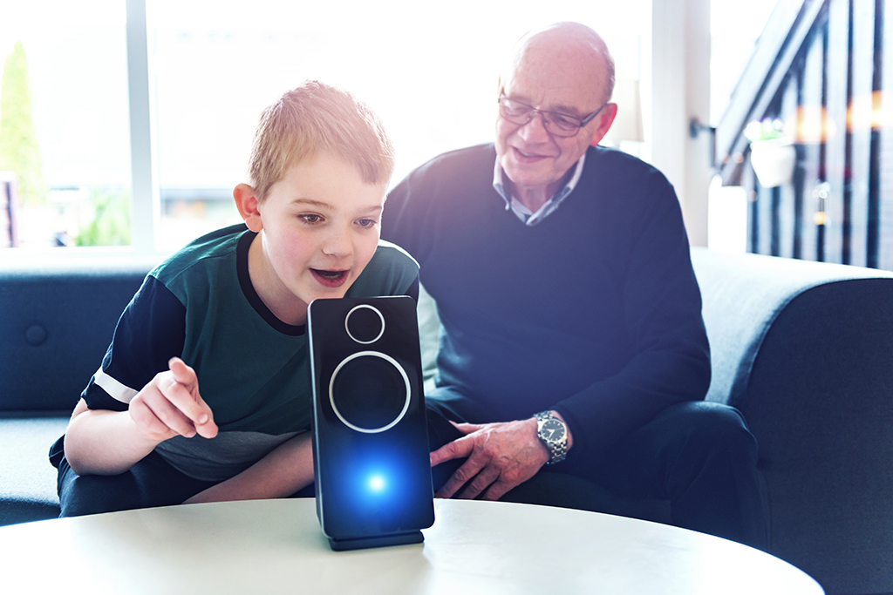

Commitments of selected organisations
The selected organisations will need to commit to the following:
- To work collaboratively with under-served audiences and communities with this programme in a high quality, engaging digital manner.
- To take an equitable approach to working with members of the community, nurturing partnerships that build trust and understand need.
- To ensure that the activities are delivered focussing on the vision, key goals and key audiences.
- To ensure two members of staff participate fully in the three Digital Engagement Masterclasses between February and June 2021. These will all be held online.
- To inspire audiences who may not ordinarily engage with STEM, to enjoy, contribute to, question and critically think about STEM, making the link between STEM and their everyday lives and interests.
- To submit the interim and final report on the dates given and to share information with ASDC for the purposes of reporting in a timely manner.
- To submit all required evaluation, on the two dates given. The format will be light touch along the lines of other ASDC national STEM programmes to create a multicentre dataset. The evaluation programme aims to assess the overall impact on the audiences you have engaged, and the impact of the programme on the way your Science Centre and staff can engage communities digitally in the future.

Programme reach and significance
We all are aware that repeated interventions generally have greater impact than short one-off interventions. This is in part the beauty and opportunity of digital and social media. In this programme we want you to play to your strengths and those of your communities.
There are no stated numbers for this programme, however the ambition is that the project creates legacy, development and change to reach new audiences.
We note the audiences can be beyond your region.
We expect many of you will do some activities with reach and some in depth and this is great.
In your application please tell us the story of why you are choosing to do what you propose, and what its significance and impact will be. For example:
- Why are you doing it?
- What outcomes do you hope for?
- Why do you want to work with these groups? What is your rationale?
- What will it allow your Science Centre to develop?
- How will this change what you do in the future?
- How many families/groups/people will you work with?
- How will you ensure it will keep people engaged?
- What is your plan to assure participation? How will you make it a success?
- How will you mitigate for Covid-19, and what are the risks to your programme?
- Can you leverage another programme to maximise who you reach?

Types of ideas that would be within scope
We want you to use your local knowledge and experience to tell us what will work for your participants and what you want to achieve working with these groups. We really want you to tell us what will be great with your communities.
- You may combine digital and non-digital (remote engagement), so long as the digital component is a vital and integral part of the interactions and engagement.
- Digital for this project covers everything from social media and on-line activities and engagement, to augmented or virtual reality, new technologies with universities, new apps or new ways to use existing apps with communities, podcasts and more. Some examples are below.
A list of examples that would be within scope of this project are on our Padlet page here: padlet.com/sciencecentres/Inspiring_Digital_Engagement and on our website as well as in the accompanying document. Please take a look at these before applying. The examples give you the flavour of the types of activities that would be eligible. At the Bidders call and the Ideation session in January you will hear about others and will be able to ask more specific questions.

What do we mean by innovative?
Innovative for this project does not need to be activities which no-one has ever done before but should be something your centre has not tried which puts audience and community in the driving seat. We are looking for proposals showing a collaborative approach and a shared sense of ownership with your communities.
This project provides an opportunity to experiment with something new in order to build trust with audiences, exchange knowledge and build public insight into the public offer.

Types of activities that would not be within the scope of this programme
We understand that all centres will be approaching this grant from a different position. Some already have an excellent digital offer and capacity to maintain it, others may be at the earlier stages of considering and evaluating their digital offer. We are keen to support centres who are at different stages of their journey in their work, however there are a few exceptions to the kind of thing this project can fund.
- The grant can’t be used for web or social media updates which are already part of your infrastructure. It could, however, be used if updates are needed to support an engagement activity as associated costs, so long as it fits the criteria in terms of a new approach for extending your audience. Centres would need to highlight what these costs are and why they are critical to support engagements.

- The Funders have been clear that making your website more inclusive in general would also not be within scope for these grants, as this is seen as activity your centre should already be undertaking. However, a project which improves the experience of a targeted group of users, such as autistic audiences or non-english speakers through collaboration with those communities would be eligible.

Note on Open Access and Intellectual Property
ASDC strives to ensure open access to all our project resources so that the field can share and benefit as a whole. Where we create resources, we licence these under creative commons (attribution, non-commercial, No derivatives, 4.0 international).
To help Science Centres continue to innovate and engage more inclusively and to find ever more brilliant ways to engage people with science, we ask that all participating centres follow this spirit of collaboration and share any new activities that evolve from the project openly, or under creative commons.

Project Key Dates
Delivery can begin from March 2021 and must be completed by the end of August 2021, reporting by Tuesday 31st August 2021.
Key dates of Project Inspire 2020 - 2021
2020
December 2020 | Project Announcement  Invitation to Participate
2021
14th January | Bidders Conference Call
21st January | Ideation Session
29th January | Proposal Application Deadline
February | - Selection Panel  - Discussions with centres  - Delivery centres notified
March | - Grant agreements signed by Science Centres  - Science Centres announced
26 March | - Science Centres can begin programmes. Please say if you want to begin earlier.  - Invoices for first grant payment received from centres to ASDC
April 4 2021 | Easter Sunday
Feb to June | Digital engagement masterclasses for the eight selected centres
31 August | - Completion of your project  - Submission of your evaluation data  - Submission of your final report to ASDC
30 September | Final grant claims from centres
30 September | Completion of the programme. Final report from ASDC to Wellcome

Reporting Data
We will collect data both during the interim report period and at the end of the project on the following:
- Numbers of people participating in your activities and what they did
- The types of activities you co-created and ran
- Demographics of who took part in your activities, where it is possible to gather this. e.g. age, gender, location.
- Further details regarding the evaluation will be covered at the Digital Masterclasses
- Any other outputs relevant to your project goals, e.g. increased numbers of followers on social media or podcast download.
- Data from this evaluation to be input and submitted to ASDC online by your centre.
- A final report of activities is required in August, including publishable photos.

Bidder’s conference call: 14th January 2021
ASDC will hold a bidder’s conference call on Thursday 14th January at 2pm, where all Science Centres interested in applying have the opportunity on a video call to hear about the programme from the ASDC team have their specific questions answered and hear the responses given to others who would be bidding.
This open framework has been used in all previous ASDC programmes, to answer questions and give clarity over what centres need to deliver, schedules, audiences, grants, budgets and reporting before each centre applies. The funders will be present at this meeting and can answer questions directly.
Please book your place on our Eventbrite page: inspire_project_bidders_call.eventbrite.co.uk

Ideation session: 21st January
This session will bring together external expertise from across the UK, alongside experts from the Science Centre sector, to showcase great ideas that have been used or are being developed to engage diverse communities in new ways through digital programmes. It will give ideas to add to your projects and embellish them and give a good idea of what types of projects you can apply for through these grants.

The Selection Process
The participating organisations will be selected through a competitive process. Organisations wishing to apply should fill in the accompanying application form. For most eligible centres this will be emailed to you.
The selection panel will be made up of representatives from ASDC and from the Funder represented by Wellcome.

Selection criteria
Priority will be given to organisations that:
- Clearly address the Project Vision, goals and key audiences.
- Show robust and interesting ideas and partnerships that others might learn from.
- Have the potential for this project to develop or change how your organisation uses digital to engage under-served families and groups in the future.

Geographic Spread across the UK
With eight Centres, we may not be able to choose a centre in each of the 4 nations of the UK. However, where all other considerations are equal, the selection panel may aim to get a geographic spread across the UK.

How to apply
To apply, please fill in the Project Inspire Application Form.
- Please send this to us as a word document.
- Please save your application form in the following format: ‘Project Inspire Digital Application from [name of your centre].
- Please email your application to Abi Ashton, abi.ashton@sciencecentres.org.uk
- Any questions, please call Abi on 07538 427 050 or Cait on 07415 409 258 (Cait is the best point of contact on Friday 29th January or Monday 1st February).
- Please CC your application to admin@sciencecentres.org.uk and ensure you get an email response saying your application has been received (re-send or call us if you do not).
- For the avoidance of doubt, and given the current situation, in the case of any issues, please phone us well in advance of the deadline if you need a day or two extension into the following week.
- Please join the Bidders' Conference Call at 2pm on Thursday 14th January 2021 and the Ideation Session at 2pm on the 21st January 2021.
- If you are unsure whether to apply or would like to ask a question please join the Bidders Conference Call. After this time, please call Abi on the number above.
Deadline for Applications: Friday 29th January 2020
We look forward to hearing from you!

